Name: ________________________________________________ Date: _______________________________
Unit 5 Study Guide
- Which graph shows the solution (3, -2)? __________________________
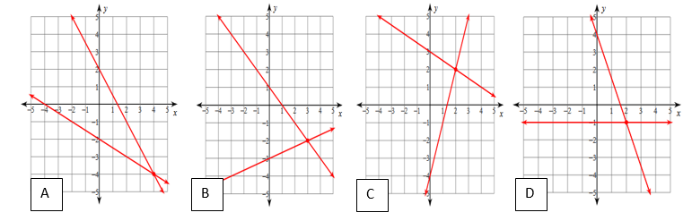

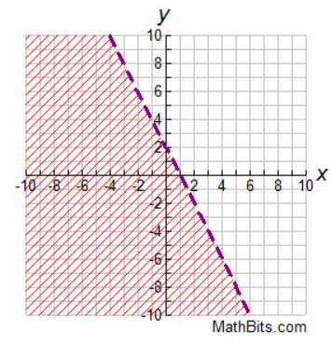
- Look at the graph:

Which of these inequalities can be represented by the graph? Select all that apply.
- y < 2x + 2
- y ≥ -2x + 2
- y ≤ -2x -2
- y > 2x - 2
- y < -2x + 2

- Solve the system if linear equations using the method of substitution. x + y = 2 and 4x + 2y = 8.

Step 1: _____________________________________________
X = 2
(2, 0)
Y = 2 – x
4x + 2(2 – x) = 8
2x = 4
2x + 4 = 8
4x + 4 – 2x = 8
Y = 0
Step 2: _____________________________________________
Step 3: _____________________________________________
Step 4: _____________________________________________
Step 5: _____________________________________________
Step 6: _____________________________________________
Step 7: _____________________________________________
Step 8: _____________________________________________
SHOW WORK HERE THEN FILL IN ABOVE!!

- A group of college students suggests a fundraiser. They want to tap the campus maple trees and make maple syrup. The group will market the syrup in two ways: bottles of syrup and maple candy. The group plans to produce 10 gallons, or 1,280 ounces of syrup.

It takes 8 ounces to make each bottle of syrup and 6 ounces for each package of candy. The students plan to produce at least 40 bottles of syrup and at least 50 packages of candy.

Let x represent the number of bottles produced and y represent the number of packages of candy produced. Which system of inequalities represents these conditions? Select all that apply.
- 8x + 6y ≤ 10
- 8x + 6y ≥ 1280
- 8x + 6y ≤ 1280
- 8x + 6y ≥ 10
- x ≥ 40
- x ≥ 50
- y ≥ 50
- y ≥ 40
- Kaden decided to use the elimination method to solve the following system of equations:
2x + 4y = 8
2x + 2y = 4

Explain what Kaden’s first step could be and why the technique of elimination provides a solution to the system of equations.

- Which graph represents the solution set for the system of inequalities below?
y ≤$\frac{1}{\begin{aligned}2 \\ \end{aligned}}$x + 2 and y < -2x -3
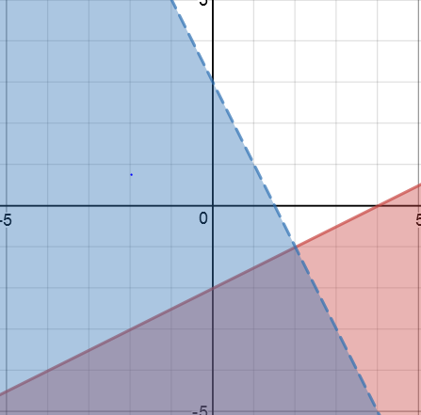
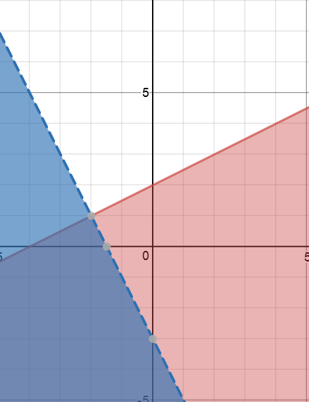
- B.

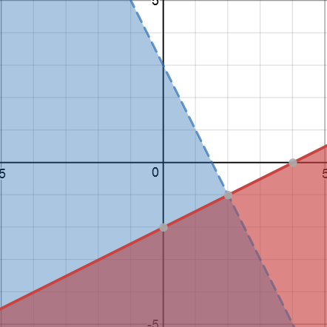
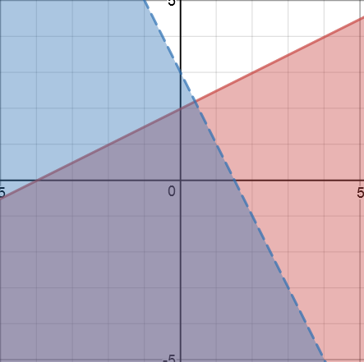
- D.

- Stephen is planning the Annual Sports Awards and Dinner which will be held at a local banquet hall. The banquet hall offers two types of tables for rent: 10-person round tables at a cost of $50 each and 6-person rectangular tables at a cost of $25 each.

Stephen needs enough tables for at least 300 people. The room can have a maximum of 44 tables due to fire codes, and the banquet hall has only 36 round tables available to rent.

Suppose x is the number of round tables and y is the number of rectangular tables that Stephen rents. The constraints x ≥ 0, y ≥ 0, x ≤ 36, x + y ≤ 44, and 10x + 6y ≥ 300 create the feasible region shown on the graph below.
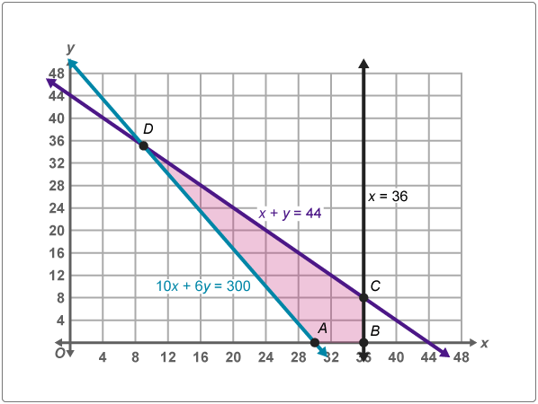

Use the graph and information given above to find the vertices of the feasible region and then complete the statement to tell Stephen how to minimize the cost of renting tables.

The vertices of the feasible region are
A (____________, ____________)
B (_____________, ____________)
C (_____________, ____________)
D (_____________, ____________)
The minimum rental amount that Stephen will pay is $________________________ when he rents
______________________ round tables and ________________________ rectangular tables.

- A ski club will sell fairly traded coffee and cocoa drinks at the annual ice sculpture festival. They can purchase coffee for $6 per pound and cocoa for $8 per pound. When they sell their cups of coffee and cocoa, the sales will equate to $20 per pound for the coffee and $28 per pound for the cocoa. The club plans to buy up to 32 pounds of coffee and cocoa, which will include no more than 10 pounds of cocoa and not less than 10 pounds of coffee. They budget up to $240 on both coffee and cocoa.

Let x represent the number of pounds of coffee y represent the number of pounds of cocoa.

If the club uses 10 pounds of coffee and 10 pounds of cocoa, their total sales will be $______________.

If the club uses 32 pounds of coffee and no cocoa, their total sales will be $______________________.

If the club uses 22 pounds of coffee and 10 pounds of cocoa, their total sales will be $______________.

- Use the elimination method to solve the following system of equations:
21x - 3y = -57
-2x + 3y = -19

- Arrange the following steps of the substitution method in order for the following system of equations: 2x – 3y = -1 and y = x – 1.

Step 1: _____________________________________________
Y = 3
Y = 4 – 1
-x = -4
-x + 3 = -1
2x – 3x + 3 = -1
2x – 3(x – 1) = -1
(4, 3)
X = 4
Step 2: _____________________________________________
Step 3: _____________________________________________
Step 4: _____________________________________________
Step 5: _____________________________________________
Step 6: _____________________________________________
Step 7: _____________________________________________
Step 8: _____________________________________________

