Name: _________________________________________________ Date: ______________

Unit 6 Test Review

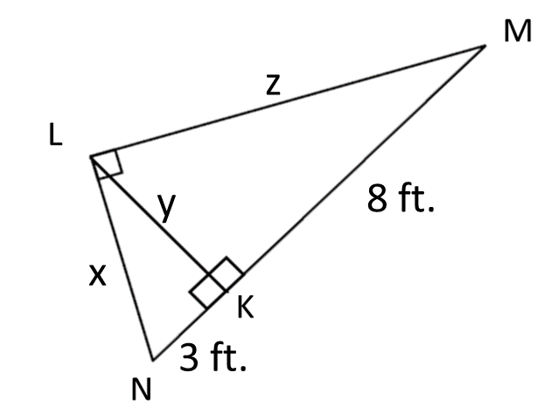Warm-Up: Identify the three similar triangles and solve for x, y, and z.

Notes:

1. Given sin $y=\frac{3}{5}$

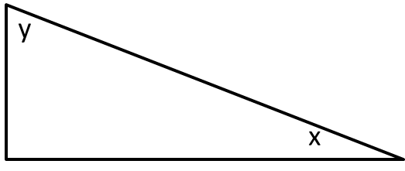 Find: sin *x* =

cos *y* =

tan *x* =

cos *x* =

tan *y* =

2. A surveyor needs to find out how far away she is from a 5,000-ft. cliff. Looking up at the cliff, the angle of elevation is 35°. How far is she from the cliff?

3. A 20-foot pole leaning against a wall reaches a point 18 feet above the ground. What is the angle which the pole makes with the ground to the nearest degree?

Classwork:

1. Identify the three similar triangles: $∆_________________\sim ∆_________________\sim ∆_________________$

Solve for x.

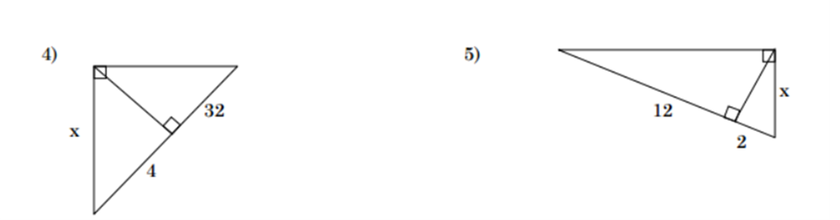

P

R

S

T

1. Identify the three similar triangles: $∆_________________\sim ∆_________________\sim ∆_________________$

Solve for *x*.

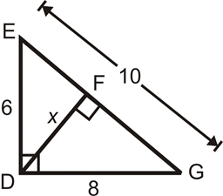

1. Identify the three similar triangles: $∆_________________\sim ∆_________________\sim ∆_________________$

Solve for *x*, *y*, and *z*.

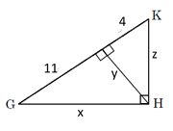

J

1. Write the definitions for the three trig functions. 5. Label O, A, and H for angle C

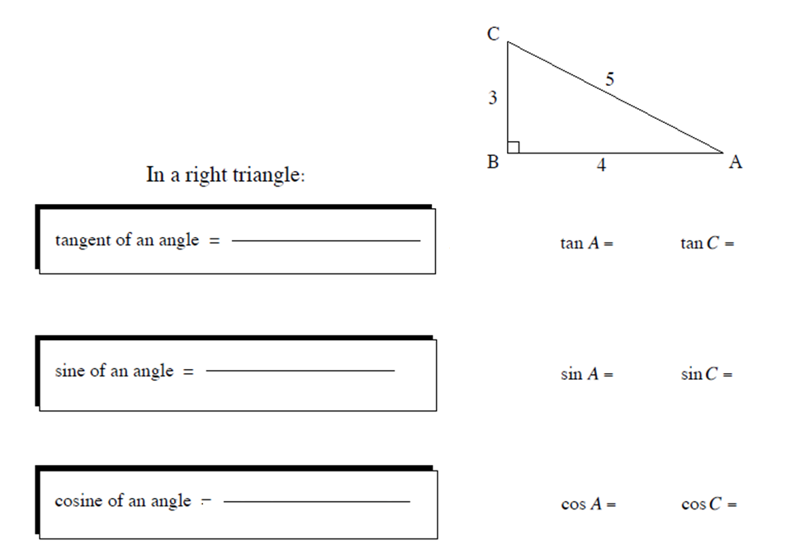



1. Given that sin *B* = $\frac{12}{20}$, find the following:

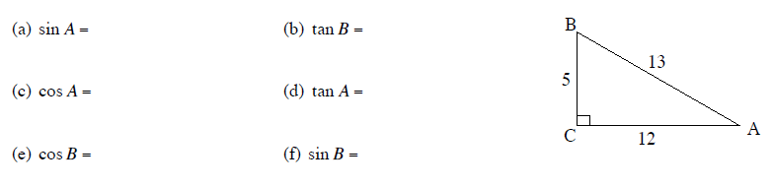

1. 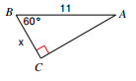 Find the missing side or angle.
2. Screen ClippingFind the missing side or angle.
3. 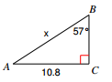Find the missing side or angle.
4. A guy wire is 15 meters long. It supports a vertical television tower. The wire is fastened to the ground 9.6 meters out from the base of the tower.

* Calculate the angle formed by the guy wire and the ground.
* Calculate how far up the tower the guy wire attaches

1. A roller coaster climbs vertically 60 meters at an angle of 30° from the lowest to the highest point of the track. It then plunges over the high point to begin the ‘fun part’. Calculate the length of the track from the bottom of the hill to the very top.
2. A truck travels 8km up a mountain road. The change in height from the bottom to the top is 1.4 km. Find the angle of inclination of the road.
3. A tree casts a 23m shadow when the angle of elevation of the sun is 52°.

* Find the height of the tree.
* Find the length of the shadow when the angle of elevation of the sun is 38°.