Name ______________________________ Date _____________________

Vertical Angles and Triangle Sum Worksheet

1. Complete the following chart with the correct angle measures:

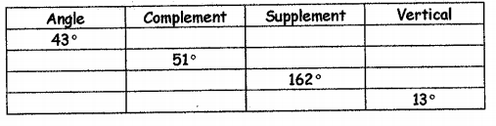

1. Name both pairs of vertical angles.

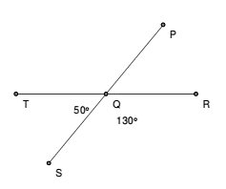

1. 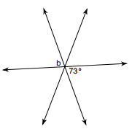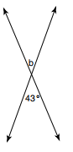Find the value of b. 4. Find the value of b.
2. X= ______________ 6. X=

$m∠1$ ______________

= $m∠1$__________ = __________

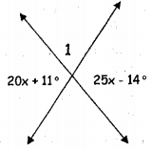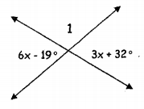

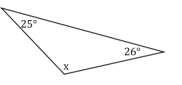For the following problems solve for the value of *x*.

1. 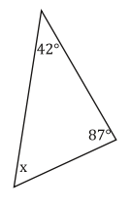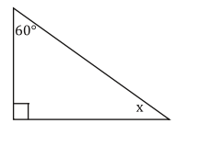 8.

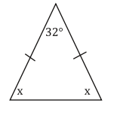

1. 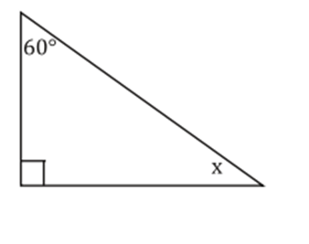 10.

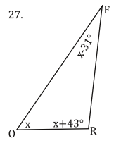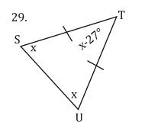

1. 12.