Name ________________________________________ Datum ____________________ Klasse: Deutsch II
Das Wetter
- Watch the video from http://cleanvideosearch.com/media/action/yt/watch?videoId=_w1qmlKg1jg / https://www.youtube.com/watch?v=_w1qmlKg1jg (YouTube search: Wetterbericht mit Untertitel). You may watch the video as many times as you need.

1. Make a list of the weather terms that you hear. Is the weatherman / woman using the same weather terms from your vocabulary list or variations of the words?

Beispiel: Es regnet. v. Es ist regnerisch.

2. In welcher Stadt ist der Wetterbericht? _________________________
3. In welcher Jahreszeit ist der Wetterbericht? ______________________

II. As a class, watch the video from http://wetter.tagesschau.de/ and make a list of the weather terms that you hear.

- Using the map below, sketch a weather map based on the notes you took in parts one and two.

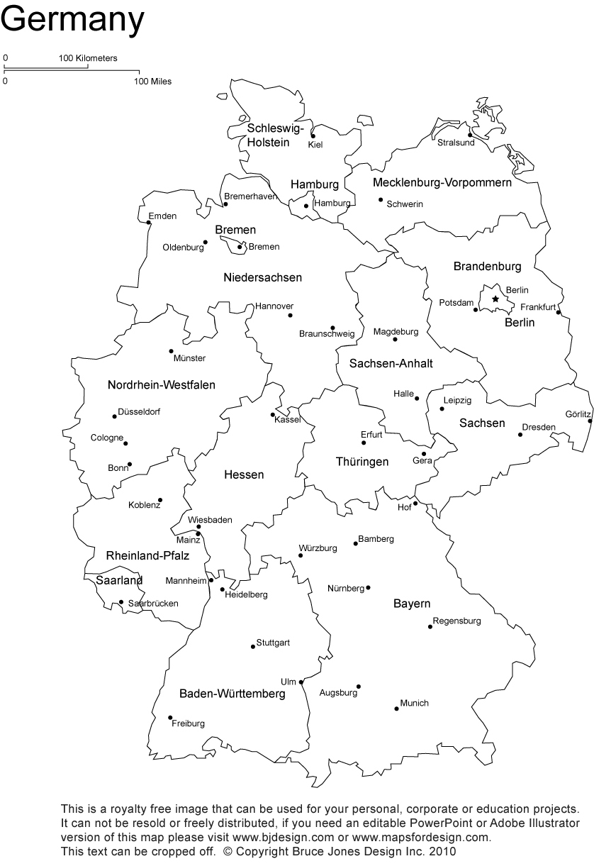

- Das Wetter Projekt
Aufgabe:
- Compare one week of weather from your home town with one week of weather in a city in Germany.
- Research the five day forecast for your home town and for the city in Germany. You may use Microsoft Word, PowerPoint, or another form of technology (please get approval from Frau Eames first) or you may hand-write your report.
- Then create a weather report that includes the following:
  - The day of the week and date in German for each day.
  - A picture of the weather and a short description for each day. The description needs to include two different weather expressions. (Beispiel: Die Sonne scheint. Es regnet. Es schneit. Es ist nass. Es ist heiß. u.s.w.)
  - The temperature in Celcius.
  - Vary your vocabulary.
  - All work should be in German.
Rubric
All work is in German. __________ 10 points
Five days of weather for American city and for a German city. __________ 10 points
The day of the week and the date are included for each day. __________ 10 points
A picture of the weather is included for each day. __________ 10 points
A short description with two different weather expressions is included for each day. __________ 20 points
The temperature is in Celcius. __________ 10 points
Grammar is correct. __________ 20 points
Creativity and neatness __________ 10 points
Total: 100 points (Summative Grade)

Step 1: Forschung (Research and rough draft)
 | Your Home town: ___________________ | Your German City: ________________
Day 1 | Datum:  Temperatur:  Wie ist das Wetter?: | Datum:  Temperatur:  Wie ist das Wetter?:
Day 2 | Datum:  Temperatur:  Wie ist das Wetter?: | Datum:  Temperatur:  Wie ist das Wetter?:
Day 3 | Datum:  Temperatur:  Wie ist das Wetter?: | Datum:  Temperatur:  Wie ist das Wetter?:
Day 4 | Datum:  Temperatur:  Wie ist das Wetter?: | Datum:  Temperatur:  Wie ist das Wetter?:
Day 5 | Datum:  Temperatur:  Wie ist das Wetter?: | Datum:  Temperatur:  Wie ist das Wetter?:

Step 2: Create your weather report. Remember you need a picture and a brief description for each day.

V. Der Wetterbericht
Du bist der Reporter / in und du berichtest das Wetter! Using the weather report you have created, give a short presentation to the class about the weather in both places. You are the weather reporter! Be sure to use props, such as maps and appropriate weather symbols.
Ideas for the weather report presentation:
-Class presentation
-Video recording of yourself giving the weather report.
-Storyboard using the website https://www.storyboardthat.com/ to create a cartoon of a weather reporter.
-You may also use a website of your choice to complete this project. Please see Frau Eames to approve your ideas.

Rubric:
Aussprache: Your presentation was completely in German and you pronounced the words correctly. 20 points
Präsentation: You behaved like a weather reporter. You were professional, you showed your audience the weather instead of simply reading the weather from a script. (If you choose the Storyboard option-your weather report needs to read like a cartoon of a weather report. It needs to make sense and include maps and weather symbols as well as dialogue.) 20 points
Grammatik: Your German was grammatically correct. 20 points
Total: 60 points

