World's oldest 'cold case'? Ötzi the Iceman's murder finally solved
Scientists have used criminology methods to find out more about who shot Ötzi in the Alps 5,000 years ago.
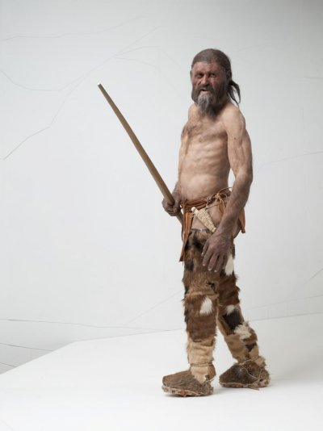
By Léa Surugue
September 26, 2016 11:29 BST

Otzi lived 5,300 years ago and was discovered in 1991South Tyrol Museum of Archaeology
The murder of Ötzi the Iceman – one of the most famous mummies in the world – was a treacherous act, taking the victim completely by surprise, scientists have said. Ötzi received a fatal arrow in the shoulder, which was shot from a great distance, potentially following a personal conflict with an enemy.
Ötzi, who is also known as the Tyrolean Iceman, was discovered 25 years ago in the Alps. He had been particularly well persevered as a glacier mummy, allowing scientists to conduct a variety of tests and discover many elements about ancestry, diet, health and lifestyle.
Over two decades, he has not ceased to fascinate scientists, not simply as an isolated mummy specimen but also because he is seen as a typical European from earlier times, bringing with him precious information about how our ancestors lived 5,000 years ago.
In 2001, ten years after scientists first discovered the Iceman, they found out the cause of his death: he had been brutally murdered. Indeed, they identified an arrow head in his left shoulder. However, the context of the death and the possible reasons for it remained a mystery.
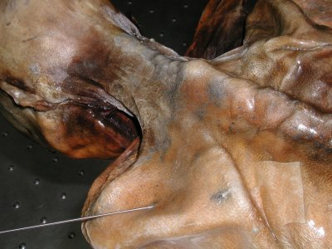
This is why in 2014, the South Tyrol Museum of Archaeology, where Otzi is kept, commissioned Chief Inspector Alexander Horn of the Munich Criminal Investigation Department to investigate the "Ötzi murder case". This was a very original approach, as the inspector was given free rein to use all the latest methods available in criminology to learn more about Ötzi's death.
The findings were presented at at the recent International Mummy Congress in Bozen-Bolzano (Italy).
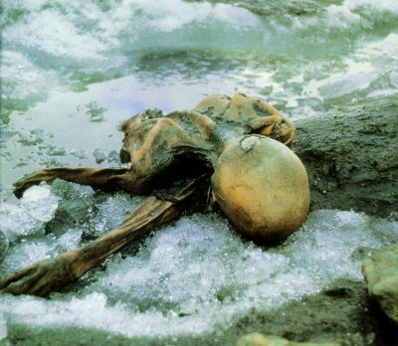
Otzi was found in the Alps and is one of the best preserved glacier mummy in the worldCourtesy of South Tyrol Museum of Archaeology
Investigating a 'cold case'
With his team, Horn interviewed archaeologists who had been working with the Tyrolean Iceman for years, as well as forensic medicine, radiology and anthropology experts. He also examined the site where Ötzi had first been found.
The investigation revealed that Ötzi had not felt threatened just before receiving the arrow. Indeed, he appeared to have been resting just before his death, after having eaten a large meal. It is probable that the arrow, shot from a great distance, took him by surprise.
Evidence suggest his assailant had been hiding not far away and decided to attack him without coming out of his hiding-place, to avoid any physical close-range combat. Ötzi fell after the arrow hit him, but there are no signs of further violence.
Scientists point to the arrow wound Otzi received and which probably killed him.Courtesy of South Tyrol Museum of Archaeology
Who was his mysterious enemy? The Iceman was found with his precious copper axe next to him, suggesting the murderer did not wish to steal from him, so the motive for the killing probably stemmed from a personal conflict. This hypothesis is reinforced by the fact scientists have identified an older, less serious injury Ötzi's right hand which they believe is the result from a previous altercation. It is possible that Ötzi was killed by the same person he had fought with, some time before.
What appears certain is that crimes in early European communities were maybe not so different than today's crimes. This is "a behavioural pattern which is prevalent even today in the bulk of murder crimes", Alexander Horn concluded.

5 Surprising Facts About Otzi the Iceman
Scholars continue to be amazed by the ancient man found frozen in the Alps.
A report that Ötzi the Iceman has 19 genetic relatives living in Austria is the latest in a string of surprising discoveries surrounding the famed ice mummy. Ötzi's 5,300-year-old corpse turned up on the mountain border between Austria and Italy in 1991. Here is a rundown of the latest on the world's oldest Alpine celebrity, and some of the other remarkable things we've learned about Ötzi.
(Read "Unfrozen" from the November 2011 issue of National Geographic magazine.)
1. The Iceman has living relatives.
Living links to the Iceman have now been revealed by a new DNA study. Gene researchers looking at unusual markers on the Iceman's male sex chromosome report that they have uncovered at least 19 genetic relatives of Ötzi in Austria's Tyrol region.
The match was made from samples of 3,700 anonymous blood donors in a study led by Walther Parson at Innsbruck Medical University. Sharing a rare mutation known as G-L91, "the Iceman and those 19 share a common ancestor, who may have lived 10,000 to 12,000 years ago," Parson said.
The finding supports previous research suggesting that Ötzi and his ancestors were of farming stock. The study used Y-chromosome markers that are passed from father to son to trace the Neolithic migrations that brought farming to Europe via the Alps. Ötzi belonged to a Y-chromosome group called haplogroup G, which is rooted, like farming, in the Middle East.
The study's overall results fit the idea that the changes of the Neolithic Revolution spurred people westward into the Tyrol region, Parson said.
He is nevertheless wary of any suggestion that Ötzi's distant relatives might be a chip off the old block, either physically or in their liking for simple grain porridge.
2. He had several health issues.
Since Ötzi's discovery in an alpine glacier more than two decades ago, scientists have subjected his mummy to a full-body health check. The findings don't make pretty reading. The 40-something's list of complaints include worn joints, hardened arteries, gallstones, and a nasty growth on his little toe (perhaps caused by frostbite).
Furthermore, the Iceman's gut contained the eggs of parasitic worms, he likely had Lyme disease, and he had alarming levels of arsenic in his system (probably due to working with metal ores and copper extraction). Ötzi was also in need of a dentist—an in-depth dental examination found evidence of advanced gum disease and tooth decay. (See video: "Iceman Autopsy.")
Despite all this, and a fresh arrow wound to his shoulder, it was a sudden blow to the head that proved fatal to Ötzi.
3. He also had anatomical abnormalities.
Besides his physical ailments, the Iceman had several anatomical abnormalities. He lacked both wisdom teeth and a 12th pair of ribs. The mountain man also sported a caddish gap between his two front teeth, known as a diastema. Whether this impressed the ladies is a moot point—some researchers suspect Ötzi might have been infertile.
4. The Iceman was inked.
Ötzi's frozen mummy preserves a fine collection of Copper Age tattoos. Numbering over 50 in total, they cover him from head to foot. These weren't produced using a needle, but by making fine cuts in the skin and then rubbing in charcoal. The result was a series of lines and crosses mostly located on parts of the body that are prone to injury or pain, such as the joints and along the back. This has led some researchers to believe that the tattoos marked acupuncture points.
If so, Ötzi must have needed a lot of treatment, which, given his age and ailments, isn't so surprising. The oldest evidence for acupuncture, Ötzi's tattoos suggest that the practice was around at least 2,000 years earlier than previously thought.
5. He consumed pollen and goats.
The Iceman's final meals have served up a feast of information to scholars. His stomach contained 30 different types of pollen. Analysis of that pollen shows that Ötzi died in spring or early summer, and it has even enabled researchers to trace his movements through different mountain elevations just before he died. His partially digested last meal suggests he ate two hours before his grisly end. It included grains and meat from an ibex, a species of nimble-footed wild goat.

