Writing Prompt for Chemistry I
Unit #1: Introduction to Chemistry, Measurement, Lab Safety, and Techniques
You will write an in-depth explanation of how to separate a mixture that is composed of five components. You will use the information below about the components in the mixture and the laboratory instruments available to construct your explanation. Use the CER framework to answer this question. Be sure to address:
- laboratory safety
- appropriate scientific vocabulary
- the method by which you will separate each component
- supporting rationale for each separation technique (That is, why will the method you choose separate a particular component?)
- whether each separation technique uses a chemical or physical change
Components in Mixture
Component | Additional Information
iron filings | magnetic
sand
sodium chloride (table salt)
water | 25 mL, boiling point = 100 °C
alcohol | 10 mL, boiling point = 78 °C

Laboratory Instruments
magnet
funnel
filter paper
heat source (hot plate or Bunsen burner)
distillation apparatus with thermometer (see figure below)
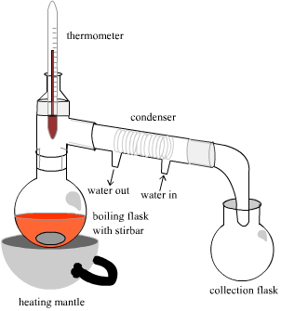
stir rod
beakers and flasks

