Name:
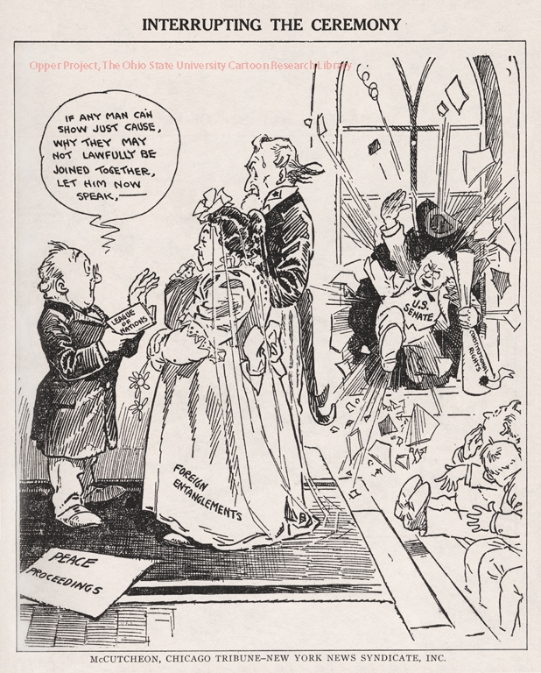

Pro or anti-league? What is the message coming out of this image?

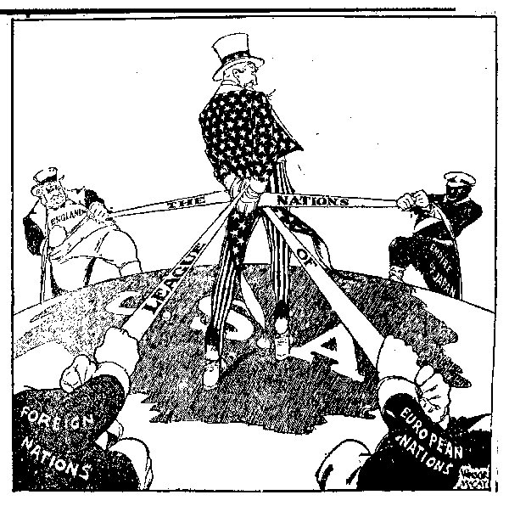
Pro or anti-league? What is the message coming out of this image?

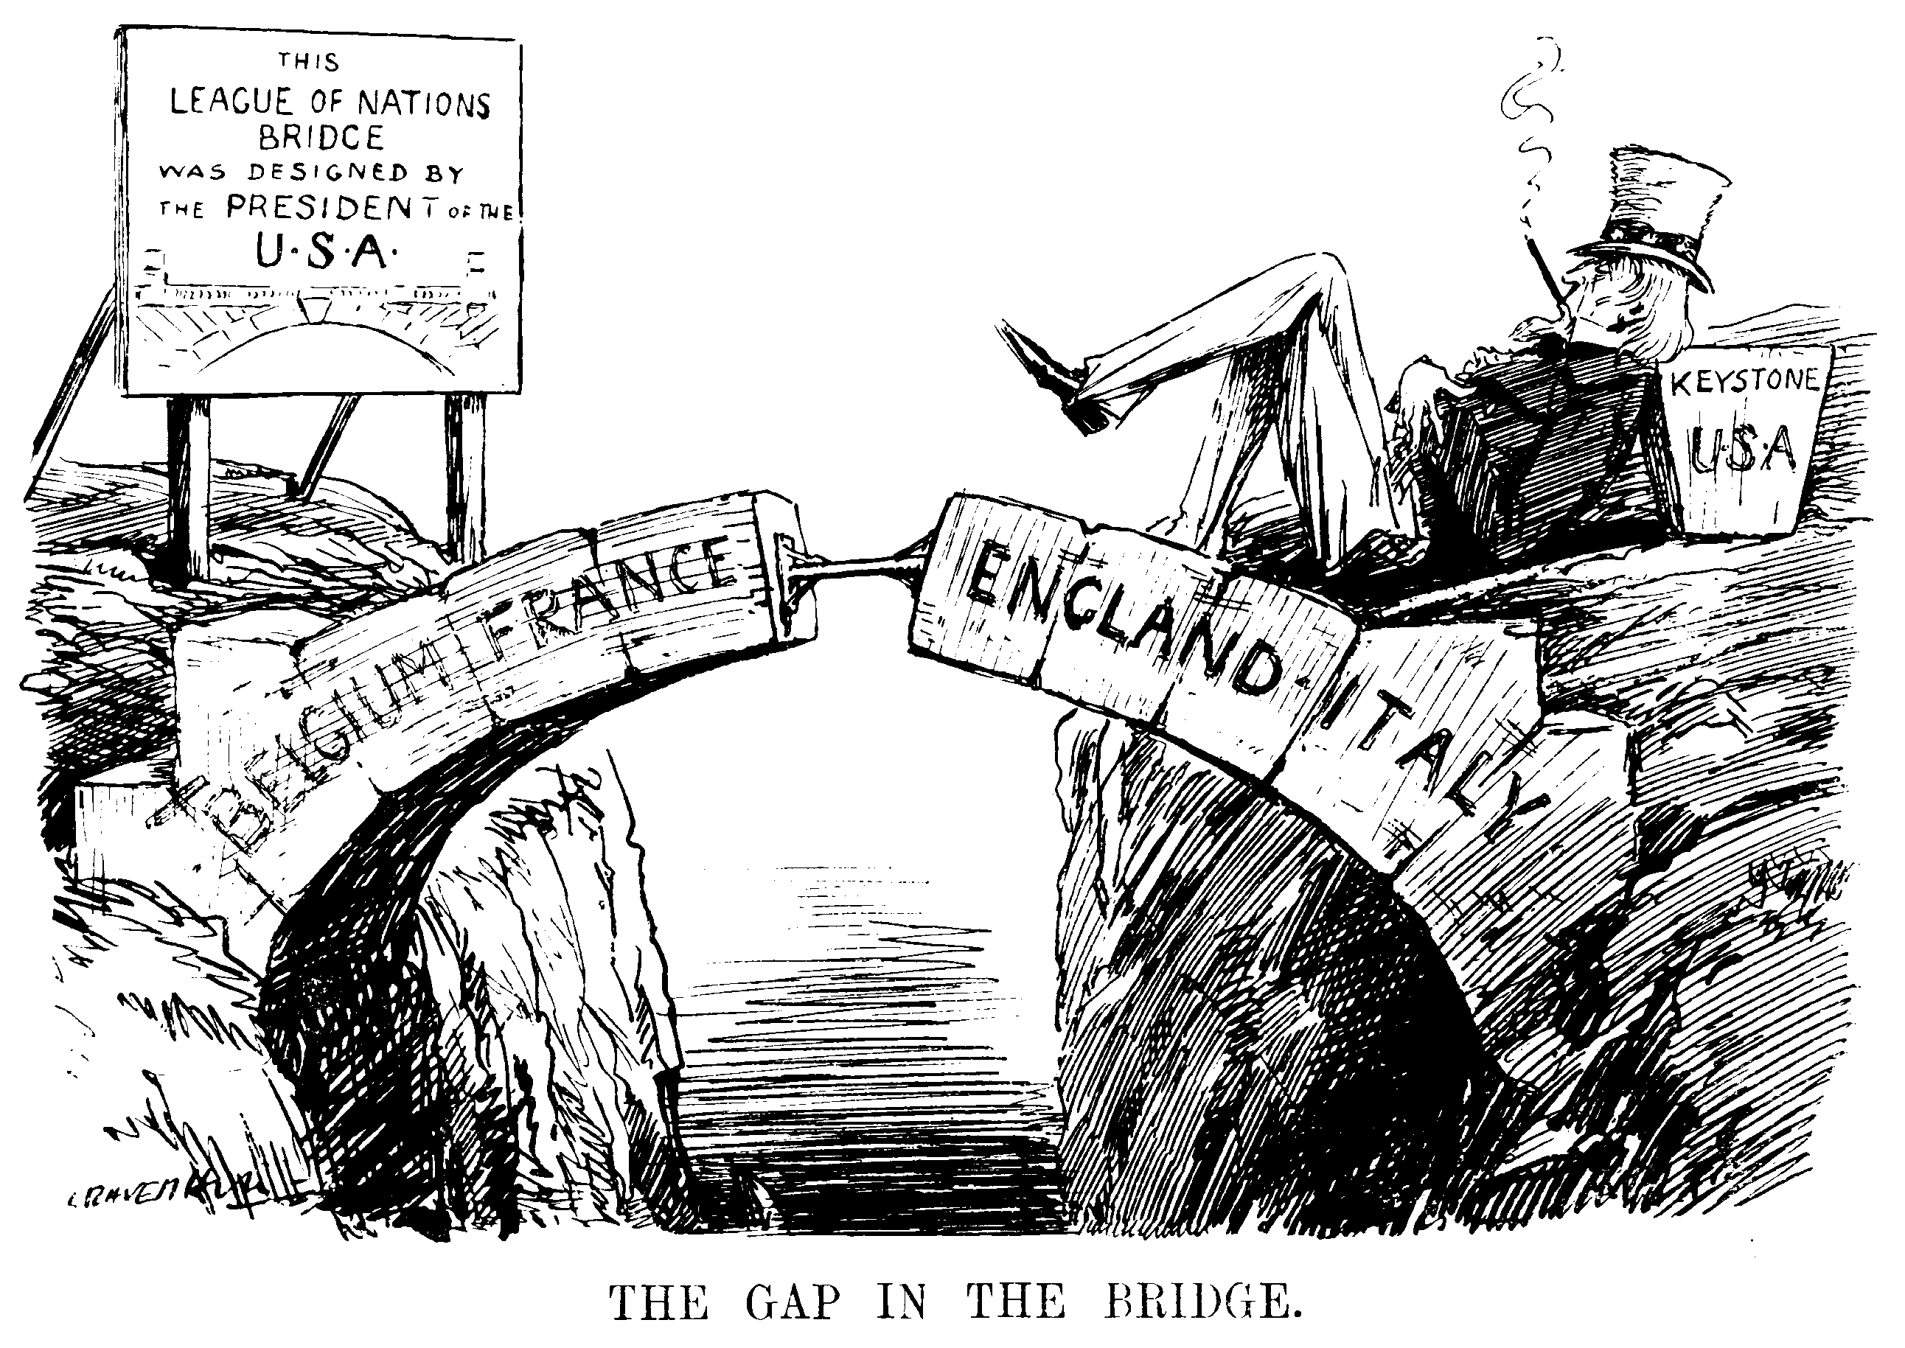
What is the message? Pro or anti-league?

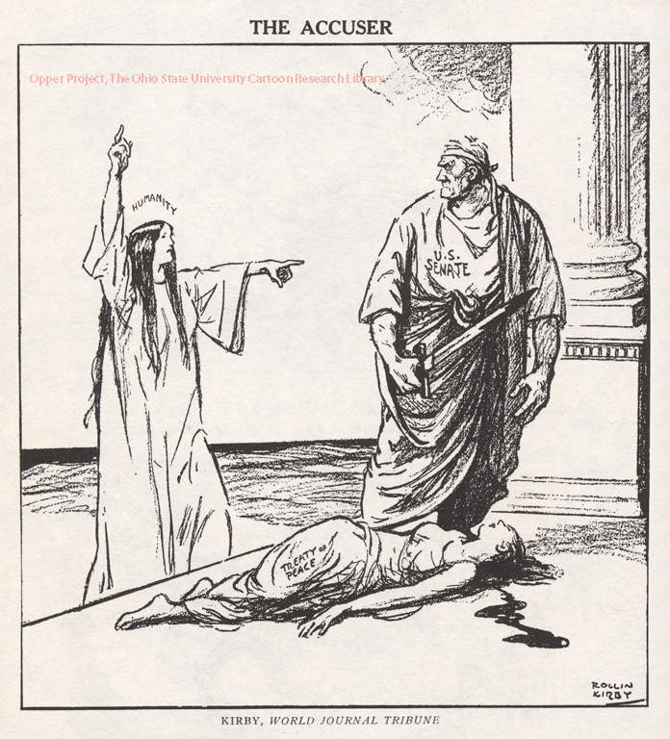
Pro or anti-league? What is the message?

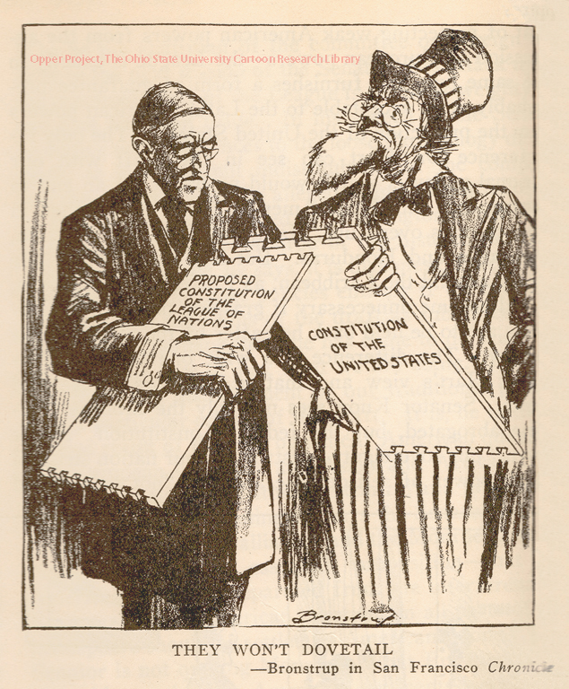
Pro or anti-league? What is the message?

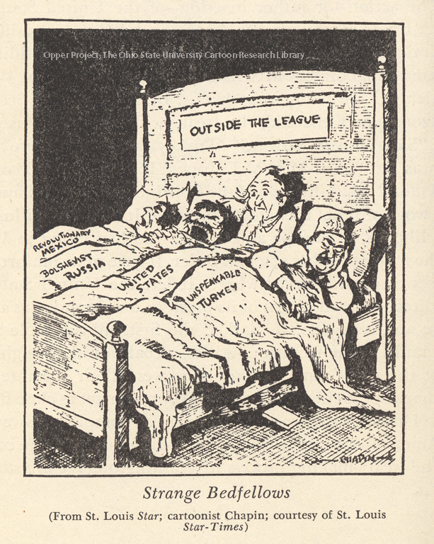
Pro or anti-league? What is the argument?

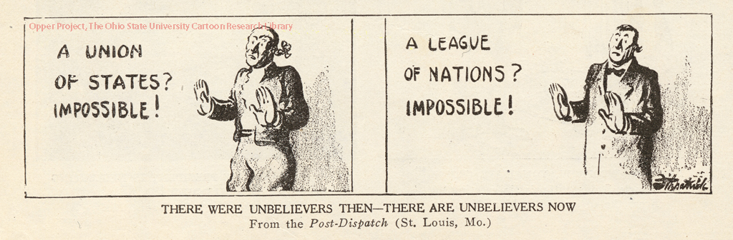

Pro or anti-league? What is the argument?

Based on your understanding of WWI and the League of Nations, write a paragraph (5-7 sentences) on the decision of the US not joining the League of Nations. Was it the right decision or was it the wrong decision?

